EX 8

docker –version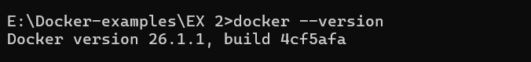

Docker-compose –version

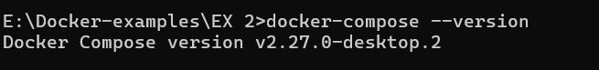

Docker build

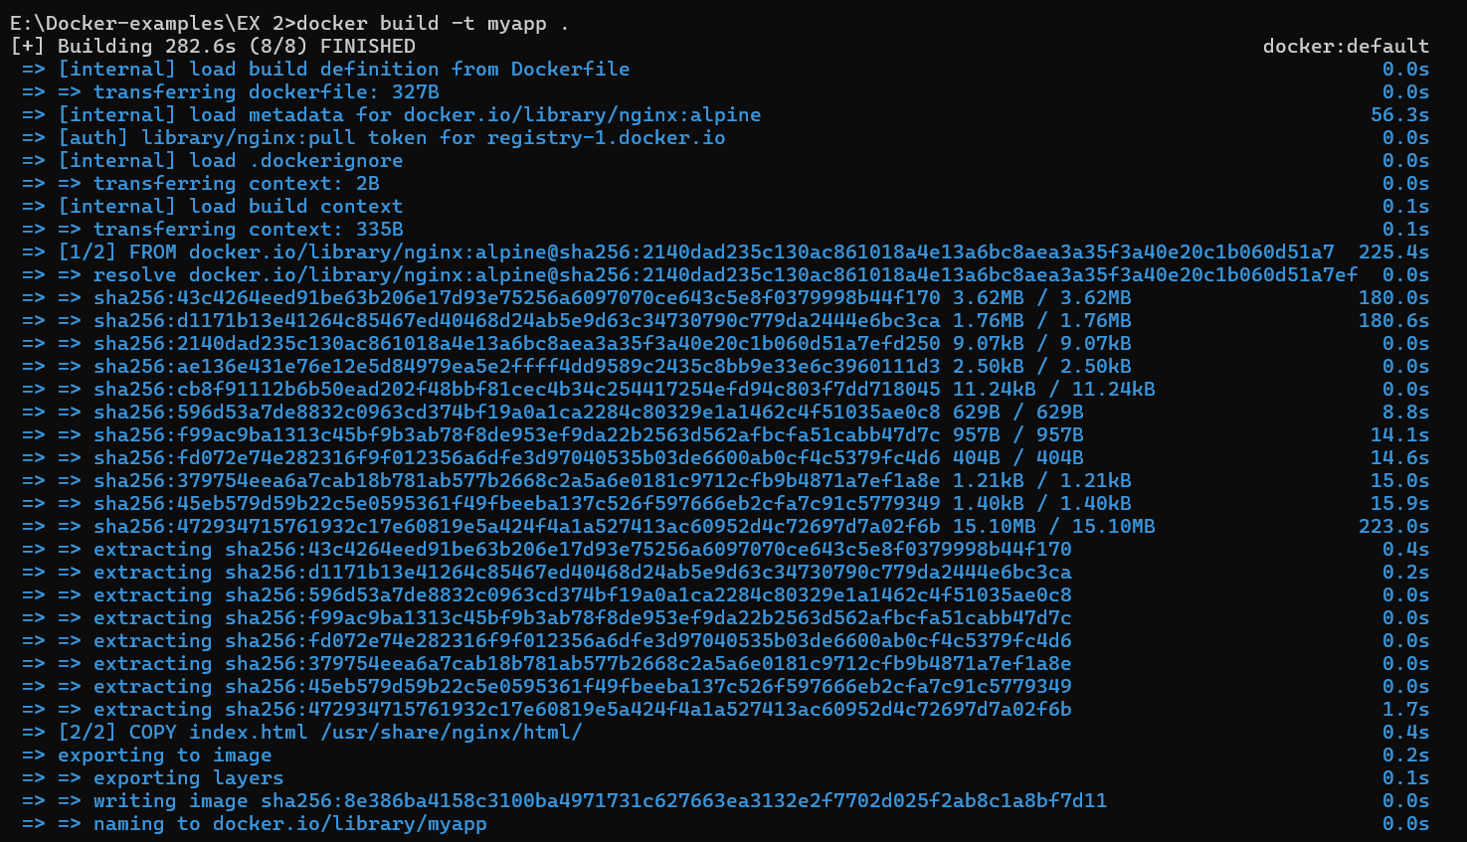

Docker run



EX 9

Docker pull

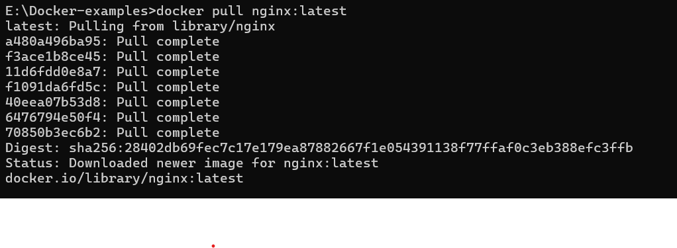

docker run --name mynginxcontainer -d nginx:latest



Docker ps

